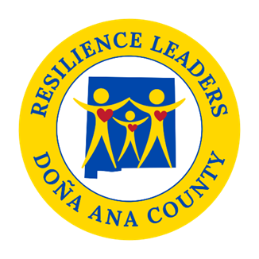

Power Hour
Friday, October 10, 2025
2:00 pm to 3:00 pm

Come join us in person at DACRL new headquarters 520 N. Campo St.
As always if you cannot make it there is a zoom option.

- 100% Family Center update- 10 minutes
- Resource Guide Update- 10 minutes
- Grant Information update- 20 minutes
- Intern Customer Service Survey- 20 minutes
- November/ December whole group meeting plan??

If Time Permits:
- Visit the evaluation process for Sector experiments (Please get clear on what your experiment will be before meeting) We will be discussing: what you are doing, why and the statements below
- How will you measure progress
- How will you know it worked?
- Is there something you need to change or redo?
- What do you need from DACRL to accomplish your goals?
This will be a working meeting, it is important you attend or send a representative.
Next meeting: November 14th, 2025, from 2pm to 3pm.
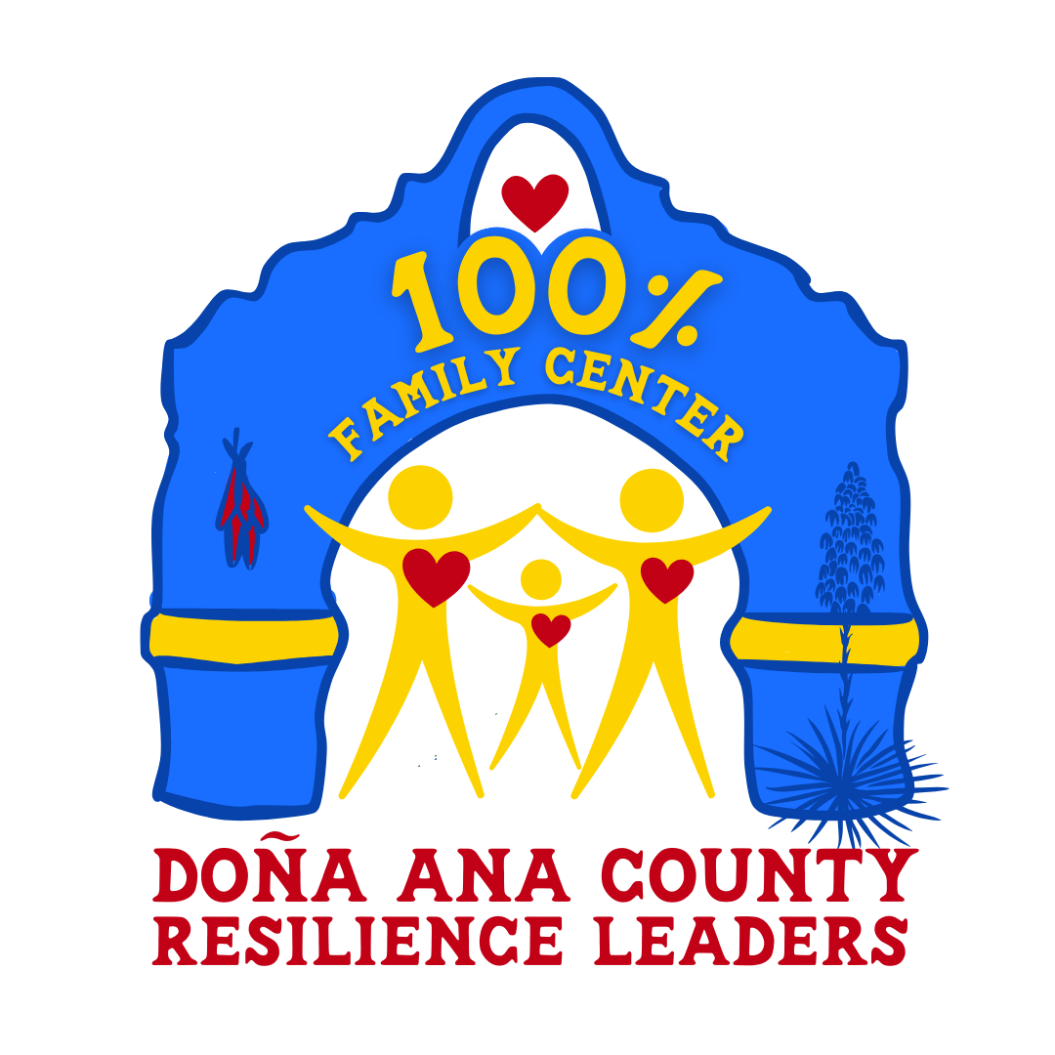
Topic: DACRL Power Hour (New Zoom Link)
Date/Time: :Every month on the Second Friday at 2 pm

Join Zoom Meeting
https://us02web.zoom.us/j/87652034178?pwd=CI6ukNPt6D97txHrAbf3uKPKaD0nWV.1

Meeting ID: 876 5203 4178
Passcode: 482609

