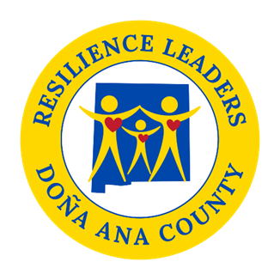

**Power Hour**

**Resilience Sector Leaders Agenda**

**Friday, June 13, 2025**

**2:00 pm to 3:00 pm**

Come join us **in person** **at DACRL new headquarters 520 N. Campo St.**

As always if you cannot make it there is a zoom option.

* **Welcome**
* **DACRL whole group new location**
* **Update 100% Family Center**

**- summer activities**

* **Visit the evaluation process for Sector experiments (Please get clear on what your experiment will be before meeting) We will be discussing: what you are doing, why and the statements below**

**- How will you measure progress**

**- How will you know it worked?**

**- Is there something you need to change or redo?**

**- What do you need from DACRL to accomplish your goals?**

**This will be a working meeting, it is important you attend or send a representative.**

**Next meeting: June 11th, 2025, from 2pm to 3pm.**

Topic: DACRL Power Hour (New Zoom Link)

Date/Time: :Every month on the Second Friday at 2 pm

Join Zoom Meeting

<https://us02web.zoom.us/j/87652034178?pwd=CI6ukNPt6D97txHrAbf3uKPKaD0nWV.1>

Meeting ID: 876 5203 4178

Passcode: 482609

