
Doña Ana County Resilience Leaders Agenda:
This meeting will be at DACC Workforce Campus room 123 and via Zoom
Friday, July 25, 2025 9:00 am to 11:00 am
- 9:00 - 9:15 Welcome, Introductions of New People

- 9:15 - 9:30 Family Center Update

- 9:30 - 10:00- LIGHT Team -

- 10:00 -10:10- Mentimeter- In one or two words describe the feeling you have when you receive good customer service

- 10:10 - 11:00 - Sector work- Customer Service Experiment (sector breakouts)

- Announcements (if time permits)
  - What’s going on in the community and county?

DACC address: 2345 Nevada AVE

*As a reminder all whole group meetings are held on the last Friday of the month,
Next meetings: Aug 29
Sept 26
Oct 31

Optional Zoom, in-person preferredJoin Zoom Meeting: https://us02web.zoom.us/j/88605694288?pwd=TmY5UmRDdHAyaFhQN0FPVERWOTc4Zz09
Meeting ID: 886 0569 4288
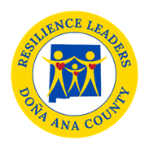
Passcode: 672632

